The Do’s and Don’ts of Formal/Academic Writing

The Do’s

- Write in a clear, “plain” style. Avoid “flowery” language at all costs! If necessary, throw out your Thesaurus! Readers are more impressed by the quality of your ideas than your use of multi-syllabic terms.
- Use active voice. Put your verbs to work for you and use direct, clear sentences.
- Vary your sentence structure. Readers get tired when they read a series of lengthy sentences with multiple clauses. Similarly, they feel rushed by a series of short, terse sentences.
- Use consistent tenses. Present tense is most common in academic papers, and should be used when referring to written texts. Future tense is almost never used.
- Have someone else read your paper before you turn it in! All writers get very involved in their own ideas and need an outside reader to provide feedback.

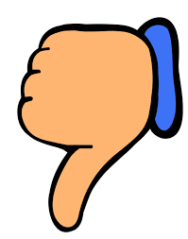 The Don’ts
- Don’t use first person pronouns ("I", "we," "me," "us," "my," and "our"). Most readers know who is writing the paper, so you do not ever have to refer to yourself.
Exceptions: some academic writing requires the use of first-person pronouns:
Tip: Never use the word “you”!
- Do not use contractions. This rule is stylistic and the goal is a “cleaner” paper. There are many exceptions to this rule and the best thing to do is check with the professor.
Tip: “cannot” is one word and “a lot” is two words!
- Don’t use slang. Only use “proper” English.
- Don’t use clichés. Be careful – clichés are easy to use. For example, “too little, too late” seems full of meaning, but it is considered vague and cliché in an academic paper.

